FOR IMMEDIATE RELEASE

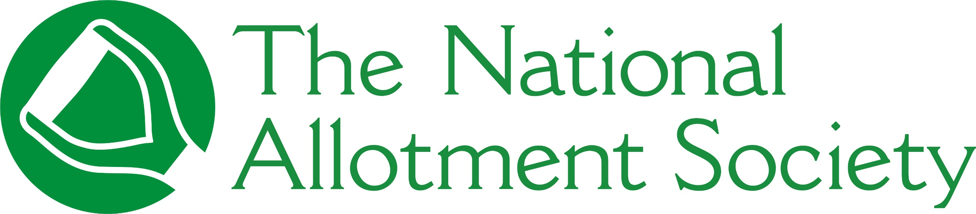

PRESS RELEASE

Wednesday 30th September, 2026

National Allotment Society calls on schools to plant the seeds for the next generation

The National Allotment Society (NAS) is calling on primary schools across the country to become members of the Society to help ensure that today’s children become tomorrow’s growers, allotment holders and champions of locally grown food.
As the UK’s leading representative for allotment holders, NAS believes that schools have an important role to play in protecting the future of allotments. It is encouraging schools to take advantage of its expertise and bring the story of food to life for children nationwide so that they understand how fruit and vegetables go from soil to plate.
The initiative comes at a time when children are increasingly removed from the processes behind the food they eat, with a recent poll of 500 children commissioned by meal kit delivery service HelloFresh revealing that one in five UK children aged 6-11 believe that fruit and vegetables begin their journey in shops, rather than being grown on farms, allotments, plants, or trees.
Garden designer, broadcaster and horticultural campaigner Adam Frost has also previously spoken publicly about the importance of children understanding where their food comes from and suggests that schools can cultivate basic crops such as potatoes, carrots, and onions to help educate pupils.
“There is real value of giving children opportunities to grow, with allotments providing pupils a place to explore a range of subjects including horticulture, nutrition, science, geography, history and healthy lifestyles,” comments Sonia Gallagher, National Secretary and General Manager at NAS.
“Plots provide a living classroom where children can discover seasonal change, develop practical skills and see first-hand the relationship between food, nature and the environment.
“If we want allotments to still be thriving in 20, 30 or 50 years’ time, we need to ensure the next generation understands what they are and why they matter. That starts with giving children the opportunity to grow for themselves – whether that be in a school garden, raised bed or part of a small windowsill project.
“Our hope is that today’s school growers will become tomorrow’s allotment holders so that plots continue to provide a vital community space for generations to come.”
As part of NAS’ commitment to help children develop an early appreciation of fresh food and discover the journey food takes from seed to plate, it has published a new picture book, Harry, Charlie and Sophie’s Allotment Adventure.

Available to buy in paperback from Amazon, at the heart of the story is the importance of giving every child the opportunity to develop the skills needed to grow food.

Schools interested in finding out more and signing up to NAS’ school membership for £10 per year, can visit https://thenas.org.uk

[ENDS]

Please direct any press enquiries to Emma Speirs on 01536 682800 or email emma.speirs@ballyhoo-pr.co.uk

NOTES TO EDITORS

Photo credit: Anna Shvets

The NAS believes that schools have a role to play in ensuring the next generation of growers understand the importance of allotments.

Copies of Harry, Charlie and Sophie’s Allotment Adventure is available to purchase on Amazon for £9.99 here: Harry, Charlie and Sophia’s Adventure

About the National Allotment Society
With over 133,000 members, The National Allotment Society (NAS) is the leading representative body for UK allotment holders. Its mission is to protect, promote and preserve allotments for future generations.

NAS works with allotment sites, associations, councils and individual plot holders to provide advice and guidance on a range of issues including site management, environmental concerns, tenancy agreements and fundraising.

For more information, go to https://thenas.org.uk/ or follow NAS on Facebook and Instagram

